# Acceptance Criteria Testing

## Story ID 3

User Story: As the owner I want to see and track the delivery times of packages for each driver so that I know if my employees are working at peak efficiency

* I can view a list of all past deliveries made.
* I can view when the driver departed for a delivery.
* I can view when the driver made the journey.
* I can view the total time of the journey.

The thought behind these pages was to give the driver the opportunity to press “start delivery” and “end delivery” buttons. The buttons would then pass the information of the assigned driver’s deliveries, total time of the journey and when the delivery would ended.

I can view a list of all past deliveries made.

**Test failed**. There is a failure in the code for viewing of past deliveries, due to failure of sending the information from driver to the coordinator for their deliveries.

I can view when the driver departed for a delivery

**Test failed**. There is a failure in the code for viewing of department of the deliveries, due to failure of sending the information from driver to the coordinator for their deliveries.

I can view when the driver made the journey.

**Test failed**. There is a failure in the code for viewing when the driver made the journey, due to failure of sending the information from driver to the coordinator.

I can view the total time of the journey.

**Test failed**. There is a failure in the code for the total time of the driver journey, due to failure of sending the information from drive to the coordinator

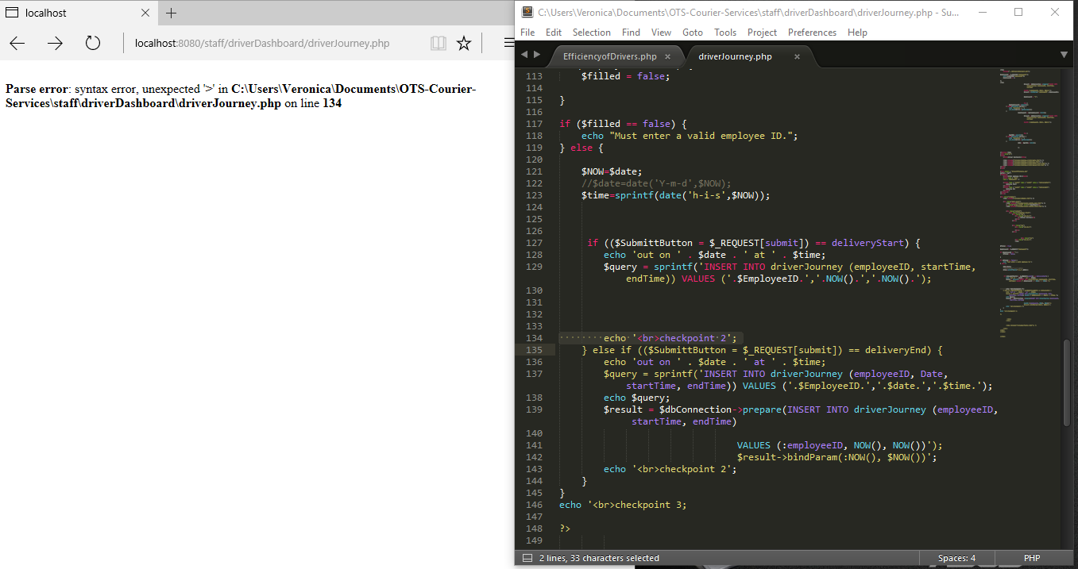

[Error for the driver journey - Drivers]

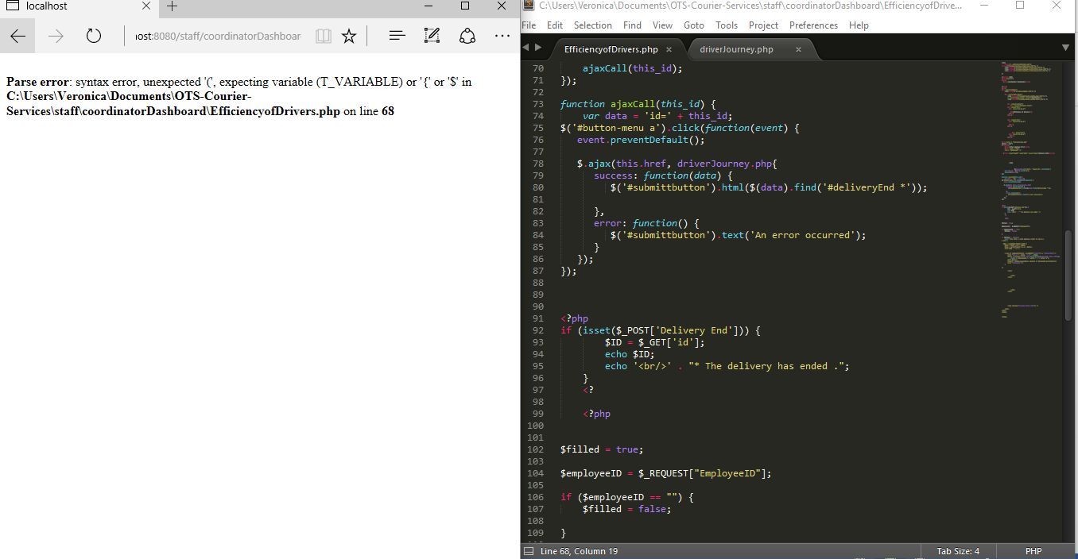

[Error in Efficiency of the drivers - Coordinator]

Jeff Jefferson is gone

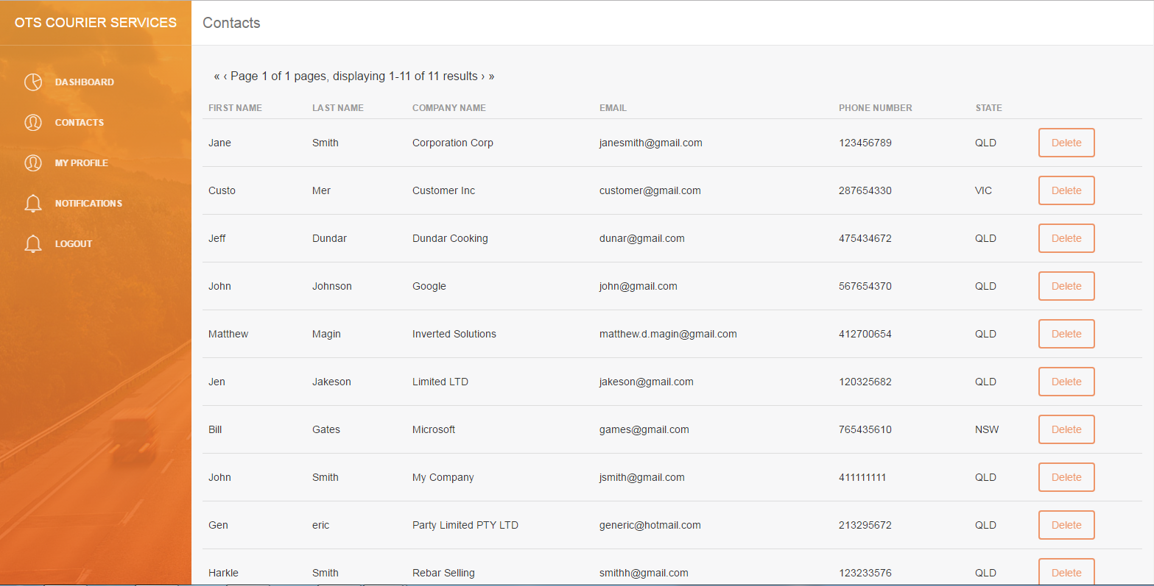

NOT IMPLEMENTED → ADD CONTACT

During development, it was found since the current iteration of the contacts page draws from the customers table and adding a contact would effectively create an account for them (complete with a password) either this function needs to be available to the customers themselves or be retooled to use a different table.